1. Write a script to calculate factorial of a number using `while` loop.

Ans.

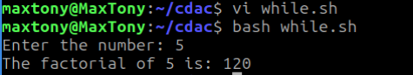

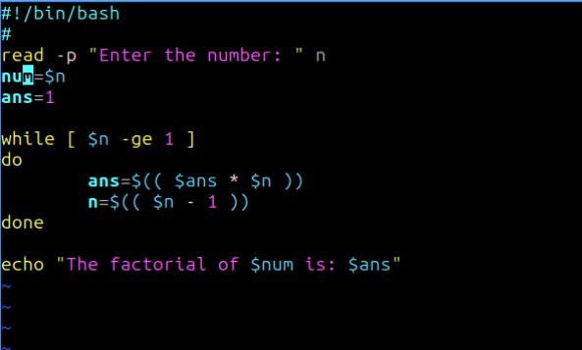

1. Write a script to display first 20 even numbers using `for` loop.

Ans.

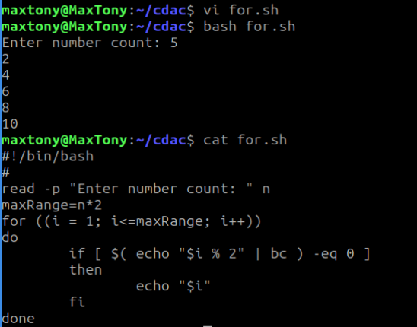

1. Write a script to print the multiplication table of a number given by the user.

Ans.

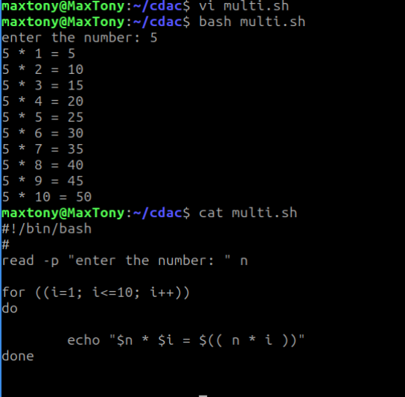

1. Write a script to count lines, words, and characters in a file.

Ans.

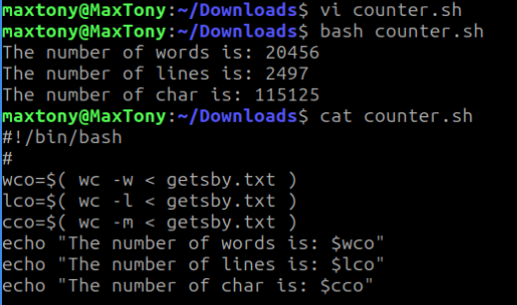

1. Write a script to display a menu (date, calendar, list files, exit) and execute the chosen option.

Ans.

